ADDINGHAM SURGERY PATIENT SURVEY RESULTS 2022
The views of our patients are very important and we value honest feedback and suggestions. In collaboration with the patient group we developed a questionnaire which was circulated during April and May 2022. A key area that the care quality commission focus on is responsiveness which is gained from feedback such as this. Thank you to everyone who has taken the time to complete the questionnaire. In total there were 130 responses and the results follow.
- What sex are you?

Of the 130 responses, 91 identified as female with 39 identifying as male. The 70% response from the female patient population as opposed to just 30% male respondents could reflect the demographic of the practice populace.
- Age group

The majority of respondents were over the age of 75 with 58 respondents were in the 56-75 age category. The 19-55 only had 10 respondents in this category. In comparison to the survey undertaken in 2018/19, the majority of respondents were in the 55-74 age range at 48%.
3. What is your ethnic group?
Of all the respondents who answered this question, they answered ‘white british’.
4. Are you a carer?
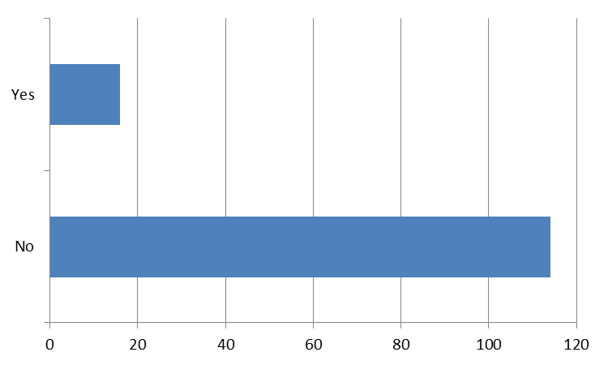
The majority of respondents indicated that they were not caring for anyone whilst 16 of the 130 who answered this question identified themselves as a carer. This is an increase of 3 from the survey undertaken in 2018/19.
5. How many months ago did you last see or speak to a GP from your surgery?

The majority of respondents’ (58), last spoke or saw a GP less than 3 months from when they answered this question with 35 answering that it has been over 12 months since they saw or spoke to a GP. This is a stark contrast from 2018/19 when only a small number, 13, answered that it was over 12 months since they had spoken to a GP and 101 had spoken to or seen a GP in 2018/19. This could be due in part to the pandemic but also that patient’s feel more able to self-manage their own care.
6. How many months ago did you last see or speak to a nurse from your GP surgery?
The majority of respondents who had contact with a nurse at the practice either face to face or by telephone answered less than 3 months to this question but in contrast to question 5, only 19 answered that it had been over 12 months since they had had contact with a nurse. These answers mirrored the results from 2018/19 with the majority of respondents having contact less than 3 months from answering the questionnaire.
7. Generally how easy is it to get through on the telephone to someone at your surgery?

The majority of respondents found getting through on the telephone very or fairly easy with only 7 out of 130 respondents not finding it easy. This hasn’t changed since the 2018/19 survey which shows the efficiency of the reception team and in this current climate is to be commended as the patient list size and demands have increased considerably in the past 4 years.
8. How do you normally book appointments to see a GP or nurse at your surgery?

A large majority of respondents use the telephone to book appointments at the practice. This could reflect the demographic of the practice population. In contrast to the 2018/19 survey results, online has seen a very slight increase whereas in person has decreased. This is probably due to the pandemic and the reduction of face to face contact.
9. As far as you know, which of the following online services does your surgery offer?

Access to services has changed over the years and ordering repeat medication was one of the first things to be introduced and used by patients in all the online services offered. E-consults have appeared since the pandemic as a way of making access to help easier and accessing your own medical record has grown in popularity over the past few years with more changes on the horizon where patients will be able to have full access to all their medical record; something we have offered at Addingham Surgery for some time. It is no surprise that the majority of respondents answered ‘yes’ to ordering repeat medication but in contrast to the 2018/19 survey there has been an increase in the number of patients who are aware of the other services offered online with only 10 out of 130 answering ‘none of these’.
10. In the past 6 months, which of the following online services have you used at your GP surgery?

61 respondents stated that they use online services for ordering repeat prescriptions whilst 63 do not use online services at all. Only a small number of respondents use online facilities for accessing their medical records, e-consult & booking appointments.
11. How satisfied are you with the hours that your GP surgery is open?

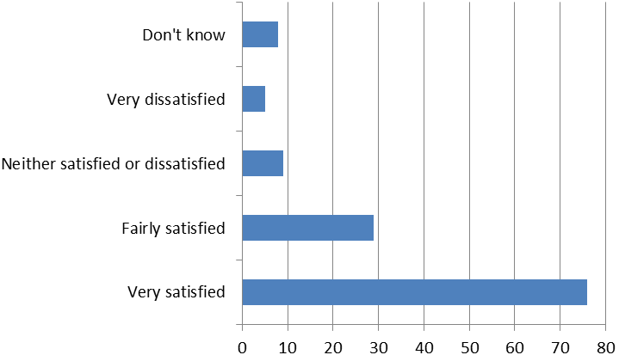
The majority of respondents were satisfied or fairly satisfied with the hours that the surgery was open with a small number neither satisfied nor dissatisfied or very dissatisfied.
12. Do you know that the surgery now offers appointments Monday to Thursday 6.30pm-8pm and weekends?

86 respondents weren’t aware of extended hours and that appointments were available evenings and weekends. More work on publicising this service needs to take place.
13. Have you used these late night or weekend appointments?

The answers to this question correlates with the previous question with 121 respondents not using the extended hours service.

14. Last time you contacted the surgery did you want to…?

The majority of respondents wanted to see a nurse the last time they contacted the surgery with wanting to see a GP the next most responded to. A small number wanted a home visit. This is in contrast to the 2018/19 survey where no respondents wanted a home visit and the majority wanted to see a GP.

15. How long after initially contacting the surgery did you actually see or speak to someone?

The majority of respondents either saw or spoke to a clinician the same day or a few days after contacting the practice. 17 answered the next working day and 14 answered a week or more later.
16. How satisfied are you with the service you get from your GP?

It is encouraging to see that 114 respondents out of 125 were satisfied or very satisfied with the service they receive from their GP, with only 4 respondents very or fairly dissatisifed.

17. How satisfied are you with the service you get from your nurse?

Responses to this question was also encouraging with the majority of respondents satisfied or very satisifed with the service they received from the nursing team with only 1 respondent who was fairly dissatisfied.
18. How satisfied are you with the service you get from the reception team?

118 respondents were satisfied or very satisfied with the service provided by the reception team with only 2 fairly satisfied and 1 very dissatisfied.

19. In general, how satisfied are you with the service you receive from the practice?

In conclusion to questions 16-19 it is positive that 118 out of 128 respondents are satisfied and very satisfied with the overall service from the practice with only 3 fairly dissatisifed.
20. Overall, how would you describe your experience of your GP surgery?

119 respondents out of 127 describe their experience of the surgery as very or fairly good with 7 stating it was fairly poor.

21. Would you recommend your GP surgery to someone who has just moved into the local area?

The majority of respondents would recommend the GP surgery to someone who had just moved into the area with 1 who would probably not recommend the surgery.
22. How satisfied are you that the practice shares your information appropriately with other healthcare professionals in your care?

The majority of respondents were very satisfied that the practice shares their information appropriately.

23. How satisfied are you that your consent is sought and your wishes respected when a request is received from a third party such as a solicitor or insurance company?

This question may not apply to all patients and this is reflected in the respondents answers with the majority stating it did not apply to them.
23. If you received your COVID vaccination at the surgery how satisfied were you with the experience?

Only 2 respondents were fairly dissatisfied with the covid vaccination service at the practice, the rest of the respondents were very satisfied or satisfied.

25. Are you aware of the existence of the PPG and VPPG?

Answer | Total
Yes | 96
No | 32
Grand Total | 128

26. Are you aware of the activities the PPG do?

Answer | Total
Yes | 59
No | 69
Grand Total | 128

