FOR YOUR INFORMATION

PRACTICE STAFF |  | ATTACHED STAFF
Practice Manager | Lizzie Lister | Citizens Advice Bureau | Via Reception
Practice Nurse | Janet Bairstow | Community Matron | Referral by GP
Practice Nurse | Amanda Fox | District Nurses | 01274 256131
Health Care Assistant | Jayne Broadbent | Health Visitors | 01943 602659
Receptionists | Jan Brown | Midwives | 01943 432066
 | Carol Campbell | Physiotherapist | Via Reception
 | Rachael Conners | Podiatrist | Referral by GP
 | Nicola Curtis | Project 6 | Via Reception
 | Hazel Griffin | Social Prescriber | Via Reception
 | Jo Wilkinson

Declaration of Interest

Dr Suleman declares he has an interest in Medical Update Ltd.

Version:: November 2018

-8-
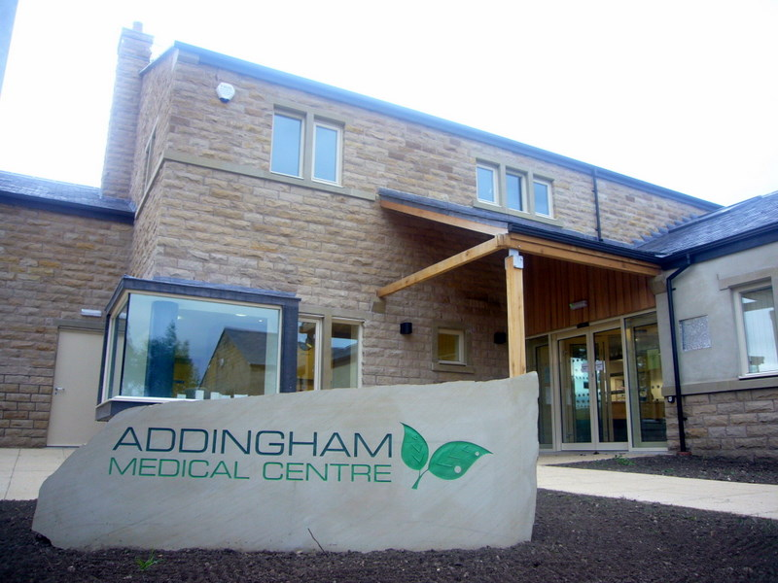

Addingham Medical Centre
151a Main Street
Addingham
Ilkley LS29 0LZ

Tel: 01943 830367
Fax: 01943 831287
www.addinghamsurgery.co.uk

Opening hours
Monday – Thursday 08:00 – 20:00
Friday 08:00 – 18:00
Saturday & Sunday – 0900 - 1100

Dr Adil Suleman – Partner – Male (GMC 4108531)
MB ChB MRCGP MBA
Qualified Dundee University 1994

Dr Andrew Bearpark – Partner– Male (GMC 4111438)
MBChB, MRCGP
Qualified Leeds University 1994

Dr Katherine Spiller – Salaried GP – Female (GMC 6074402)
MBChB, MRCGP
Qualified Leeds University 2003

The practice is supported by healthcare workers including:
Cardiology District Nurses Podiatry
Community Matron Health Visitors School Nurse
Citizen’s Advice Bureau Midwives Social Prescriber
Practice Nurse Physiotherapy

INTRODUCTION

Addingham Medical Centre provides GP services to the village of Addingham as well as the surrounding villages of Draughton, Bolton Abbey, Silsden and Ilkley.
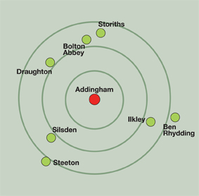
The practice is situated in Addingham Memorial Hall Car Park within walking distance of the bus stop with plenty of parking spaces.

Dr Adil Suleman took over the surgery in 2006 from Dr Raubitschek. He graduated from Dundee University in 1994 and qualified as a GP in 1999. He worked in various practices in West Yorkshire before working in Addingham. Dr Suleman works on a Friday.

Dr Andrew Bearpark qualified as a GP in 1994 and has worked in a variety of practices in the area. He works Monday to Thursday.

Dr Katherine Spiller qualified as a GP in 2003 and has a special interest in Women’s Health and Elderly Care. She works on a Monday and Thursday.

The staff comprise of highly qualified, dedicated receptionists and secretaries. They are always ready to help patients. Some of the problems of flexibility of appointments and visits can be improved if you would kindly indicate something of the nature of the problem. They are bound by the same rule of confidentiality as the doctors.

ACCESS FOR PATIENTS WITH DISABILITIES AND MOTHERS WITH BABIES

Easy access is provided for wheelchair users and prams/buggies at the front entrance. Staff are happy to assist anyone with difficulties who requires help. Baby changing and breast feeding facilities are available within the surgery. Please ask at reception.

SERVICES AVAILABLE
We offer a full general practice service including:

◻ Asthma  ◻ Arthritis  ◻ Blood pressure  ◻ Cardiology Consultant Clinics  ◻ Cervical Cytology  ◻ Child Health/Immunisations  ◻ Citizen’s Advice Bureau  ◻ Coronary Heart Disease  ◻ Counselling  ◻ Diabetes  ◻ Family Planning and Contraception | ◻ Health Visitor  ◻ HRT & Menopause Care  ◻ Long Term Condition Management  ◻ Mental Health  ◻ Physiotherapy  ◻ Podiatry (NHS and Private)  ◻ Project 6  ◻ Social Prescriber  ◻ Smoking Cessation  ◻ Travel Vaccinations  ◻ Warfarin Monitoring

-2-

USEFUL TELEPHONE NUMBERS
Out of Hours Emergency | 0845 1294402
NHS Direct | 111
District Nurses | 01274 256131
Pharmacies
Boots – Ilkley | 01943 816959
Lloyds Pharmacy – Ilkley | 01943 607227
Ilkley Moor Pharmacy | 01943 604206
Rowlands, Addingham | 01943 831462
Hospitals
Airedale General Hospital | 01535 652511
Bradford Royal Infirmary | 01274 542200
St Luke’s Hospital, Bradford | 01274 734744
Leeds General Infirmary | 01132 432799
St James’ Hospital, Leeds | 01132 433144
Wharfedale General Hospital | 01943 465522
Coronation Hospital | 01943 609666

NHS England
NHS England is increasing transparency in the NHS and improving services for patients. They work with NHS staff, patients, stakeholders and the public to improve the health outcomes for people in England. Their contact details are:

NHS England
PO Box 16738
Redditch B97 9PT
Tel: 0300 311 22 33 (Monday to Friday 8am to 6pm, excluding English Bank Holidays)
Email: england.contactus@nhs.net

-7-

PRIVACY
If you would like to discuss a matter in private with a receptionist or other member of staff please ask.

NHS CENTRAL RECORDS SERVICE
Any patient may refuse consent for their records to be uploaded to a national shared electronic record. Please speak to Reception if you wish to opt out of this service.

PATIENT PARTICIPATION GROUP (PPG)
The PPG meets every twelve weeks and acts as a link between patients and the practice. If you would like further information or would like to join the group please ask reception.

NON-NHS WORK
Certain medical examinations, vaccinations, forms, letters and certificates cannot be provided under the NHS. Please ask at reception for details of these charges.

VIOLENT AND ABUSIVE PATIENTS
We aim to treat our patients courteously at all times and expect our patients to treat our staff in a similar respectful way. We take seriously any threatening or violent behaviour against our staff or our patients. If a patient is violent or abusive they will be warned to stop their behaviour. If they persist, we may exercise our right to take action to have them removed, immediately if necessary, from our list of patients. NHS England will register all such patients on its Violent Patient list.

INTERPRETERS
With advance notice we are able to arrange for an interpreter to be present at your appointment.

WALK IN CENTRES
The nearest walk in centres are:

Hillside Bridge Health Centre Shakespeare Medical Practice
4 Butler Street West Cromwell Mount
Bradford BD3 0BS Leeds LS9 7TA
Tel: 0845 1211024 Tel: 0113 2951132

-6-

REGISTRATION
To register as an NHS patient you must be eligible under NHS regulations. In general terms this means you must be an EU citizen permanently living in the UK. For all patients over 16 the practice will ask for photographic evidence of your status e.g. driving licence or passport AND a utility bill.

HOW TO REGISTER
If you live in our practice area and would like to register with us please complete one of our registration forms available from Reception. Once completed please return these forms to reception together with your forms of identification. Alternatively you may wish to download the relevant forms on line at http://www.addinghamsurgery.co.uk/new-patients. All new patients will be invited to attend a new patient health check. Once registered it is not always necessary to see the GP with whom you have registered – you may ask to see any of the doctors and whilst we make every effort to comply with patients’ requests for a preferred doctor, this may not always be possible.

TEMPORARY REGISTRATION
People who are staying in the area may register at the practice for urgent medical problems whilst away from their usual home (provided they are eligible for NHS treatment – see above). Please be aware the practice will not have immediate access to any of your previous medical records.

RIGHTS AND RESPONSIBILITIES OF THE PATIENT
Patients have a responsibility to advise the practice of any change to their name, address or telephone number. Please note that for a name change we require documentary proof.

NAMED DOCTOR PREFERENCE

The named GPs for Addingham Medical Centre are Dr Adil Suleman and Dr Andrew Bearpark . Patients have a right to express a preference to receive services from a particular practitioner within the practice, which will be recorded in writing. Whilst we make every effort to comply with such requests for a preferred doctor, this may not always be possible.

APPOINTMENTS
The practice operates an appointment system to help prevent patients waiting for long periods and to regulate the clinical work. Ten minutes is the standard appointment length. Patients telephoning before 09:00 with an urgent medical problem will be offered an appointment that day.

Appointments may be booked up to 3 months in advance. Over a third of GP appointments are available to book on the day.

We also offer telephone appointments with a GP during surgery time should a face to face consultation not be necessary.

-3-
Please telephone or call in to the surgery to book an appointment and ask for a separate appointment for each person to be seen. If you are unable to keep your appointment please advise us as soon as possible so that we can offer your appointment slot to another patient. If you have not seen a doctor for three years (or in the last 12 months if you are over 75 years) we will be pleased to provide you with a health check.

EMERGENCIES – DURING SURGERY HOURS
For an URGENT problem or in a medical EMERGENCY between 08:00 and 18:00 please telephone 01943 830367.

EMERGENCIES – OUT OF HOURS
In emergency after 18:00, please telephone the surgery on 01943 830367 and you will be diverted to Local Care Direct or asked to call NHS111 free of charge.

HOME VISITS
Doctors will only visit those patients who for medical reasons cannot visit the surgery. Doctors do not have access to patient records when they do home visits. It is safer for a patient to be seen in surgery than at home. We therefore advise that should you be unable to attend the surgery and you need a home visit please telephone before 10:30.

TELEPHONE ADVICE
We offer telephone appointments with a doctor for non-urgent medical problems and simple advice. Please book in with reception before 10:30. The doctor will ring you back between the morning and afternoon surgeries.

REPEAT PRESCRIPTIONS
Please allow (between request and collection) a minimum of two working days (excluding weekends and Bank Holidays) for your new prescription to be issued.

In order to obtain a repeat prescription please do one of the following:
- hand in your request personally or through the letter box;
- post your request. If you enclose a self-addressed stamped envelope we will post this back to you;
- go to https://systmonline.tpp-uk.com/2/Login?PracticeId=B83620&Date=20160210131947
and follow the link on ‘How to order a prescription’
- fax your request to 01943 831287.

Arrangements can be made for your prescription to be collected by Rowlands Addingham, Lloyds Pharmacy, Boots, Ilkley Moor Pharmacy or Mitchells. Please ask for details. For safety reasons it is not possible to accept telephone requests for prescriptions

.-4-

SYSTMONLINE FOR APPOINTMENTS & PRESCRIPTION REQUESTS
The practice provides an on-line booking service called SystmOnline for appointments and ordering repeat prescriptions 24 hours a day, 7 days a week. You must obtain a unique USER NAME and PASSWORD before you can take advantage of this service. Please speak to reception. Photographic proof of identity must be brought with you when registering e.g. driver's licence or passport. If you would like to register on behalf of another person, written consent and their photo ID will be required to register them with this service. For those under 16, any proof of identification such as a Birth Certificate will be accepted.

TEST RESULTS
Please telephone after 14:00 for test results and allow a minimum of:
3 days Blood tests
7 – 10 days X-rays

REFERRAL TO SECONDARY CARE (HOSPITAL CHOICE)
If the GP is referring you to a hospital for further investigations, please be aware that there is a choice of hospitals available to you. Please check with the GP at the time of your referral consultation.

COMPLAINTS AND COMMENTS ON THE PROVISION OF SERVICES
All of the staff or doctors are available to hear about any matter which relates to the welfare of patients or the running of the surgery. Alternatively you may wish to complete a Practice Complaint Form, which may be kept anonymous if desired, and sent to the Practice Manager.

HOW ARE WE DOING?

We are constantly trying to improve our service and welcome your suggestions for improvement.

CONFIDENTIALITY
Patient information is treated with the utmost confidentiality and is released only in line with the Data Protection Act, the Freedom of Information Act and the Caldicott Guidelines.

DATA PROTECTION
A patient’s written consent would always be obtained if a request for access to their medical records were received from any other agency.

FREEDOM OF INFORMATION
Information about the practice and the doctors is publicly available. For a printed copy please enquire at the reception desk. The information is also published on our website.

-5-

